|  |
| --- |
| MPI Project |
| Home Automation |
| Using Ubidots Server |



**Members:**

Muhammad K17-2421

Waleed Aijaz K17-2442

Ariba Ehtesham K17-2374

Contents

Abstract: 2

Introduction: 2

Methodology: 2

Hardware Requirement and cost analysis: 3

Ubidots Output: 3

Circuit Diagram: 4

Conclusion: 4

# Abstract:

With the rise in IoT applications and its demands, this is a basic and most important project to start with. This gets the data from Ubidots Server and controls the relays that have 220V AC supply and is directly connected to the main appliances. This project is in convience as it has an LCD interface, Power meter to monitor the voltage and current flowing in real time. The entire project is encloased in a wooden frame for safety reason. The project is rated 5A as max current bearable.

# Introduction:

Using the Ubidots server to controll relays and publish power readings to the server with the help of MQTT protocol, that helps in keeping ESP32 synchronized with the serverfor every new change, and will make changes to the circuit. The 5V AC Relay Module of 4 relays is used to use the 220V main supply as source for every device, that we are controlling.

# Methodology:

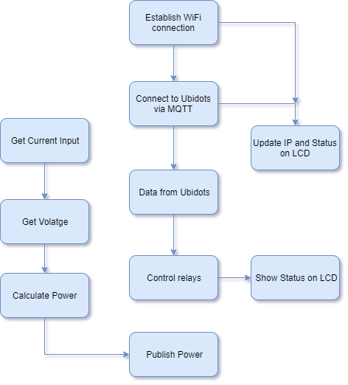

# Hardware Requirement and cost analysis:

|  |  |  |
| --- | --- | --- |
| Component | quantity | per unit cost |
| esp32 | 1 | 850 |
| lcd 16x2 | 1 | 200 |
| relay module 4 channel | 1 | 300 |
| acs712 | 1 | 300 |
| zmpt101b | 1 | 350 |
| Wooden frame | 1 | 150 |
| 2-way switch | 4 | 30 |
| socket | 5 | 30 |
| wires | 3 meters | 25 |
| jumper wires | 1 set | 100 |
|  |  |  |
|  |  |  |
| Net Total: |  | **2595** |

# Ubidots Output:

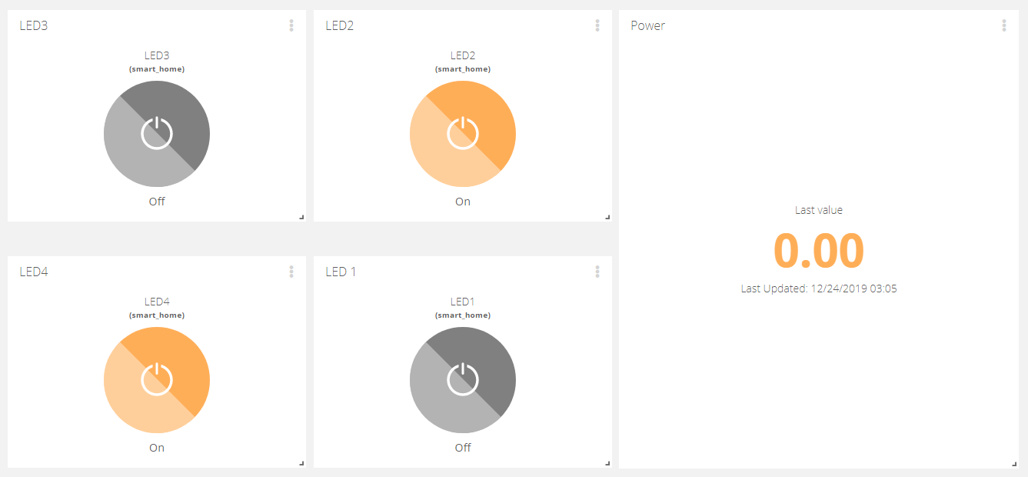

# Circuit Diagram:

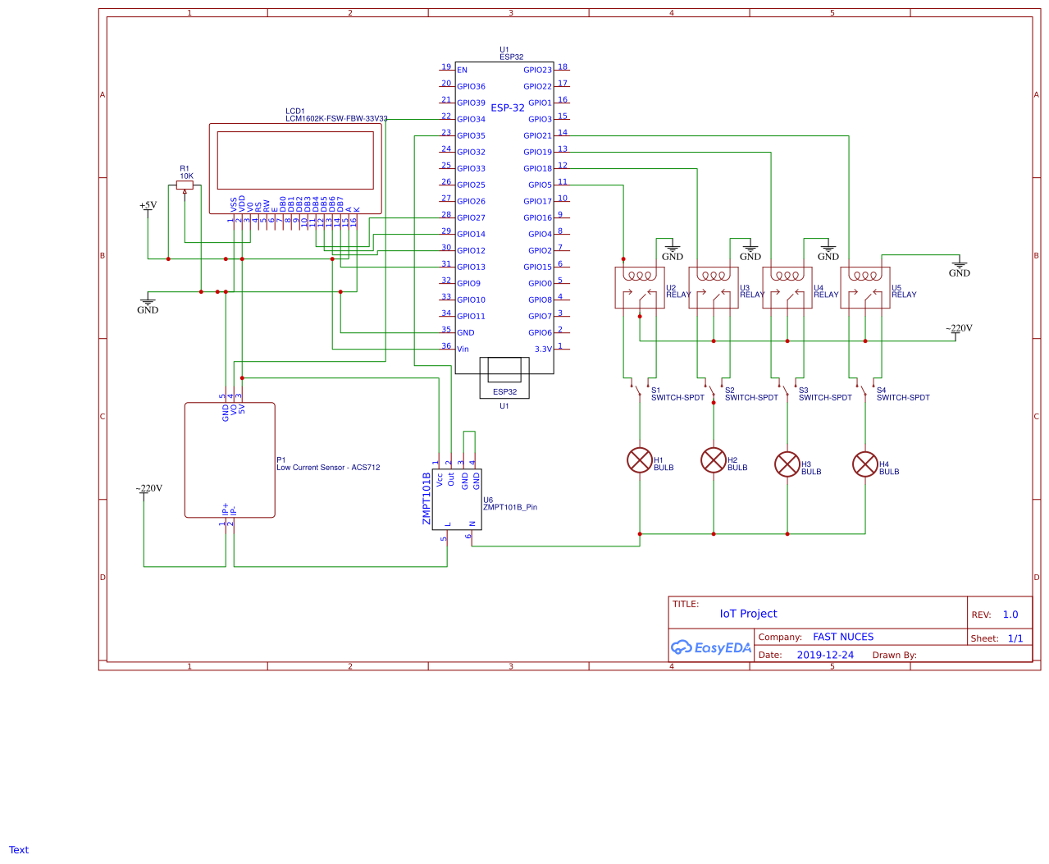

# Conclusion:

The art of making the things smart actually begins with simple controlling them wirelessly or remotely. This project achieves the milestone in a great way and performs the desired task as it should be. This is just an initial step to the coming industrial revolution of smartness in things globally.